Footprints Dance Alliance
Dress Code

Creative Movement
Any color leotard and/or dance dress
Pink Tights
Pink Leather Ballet Shoes
Tan Mary Jane Tap Shoes (Starting in January)

Prep I
Any color leotard and/or dance dress
Pink Tights
Pink Leather Ballet Shoes
Tan Mary Jane Tap Shoes

Prep II
Any color leotard and/or dance dress
Pink Tights
Pink Leather Ballet Shoes
Tan Marty Jane Tap Shoes
Tan Slip On Jazz Shoes (no laces)

Ballet I, II, III and IV
Black Leotard
Pink Tights
Pink Leather Ballet Shoes
Black Ballet Skirt (Optional)
Pointe Shoes at the discretion of the Ballet Instructor
-We will take you to be fitted when the time comes

Tap I, II, III and IV
Any Color Leotard
Any Color Dance Booty Shorts (Optional)
Tan or Pink Tights
Tan Slip On Tap Shoes (no laces)

Jazz I, II, III and IV
Any Color Leotard
Any Color Dance Booty Shorts (Optional)
Tan or Pink Tights
Tan Slip On Jazz Shoes (no laces)

Lyrical I and II
Any Color Leotard
Any Color Dance Booty Shorts (Optional)
Tan or Pink Tights
Tan Slip On Jazz Shoes

Hip Hop I, II and III
Comfortable and Loose Modest Clothing
Black High Top Converse Style Sneakers

Acrobatics I and II/Tumbling I and II
Any Color Leotard
Any Color Dance Booty Shorts (Optional)
Tan Footless or Convertible Tights

Musical Theater
Any Color Leotard
Any Color Dance Booty Shorts (Optional)
Tan Tights
Tan Slip On Jazz Shoes

Irish
Any Color Leotard
Any Color Dance Booty Shorts (Optional)
Tan Tights
Black Leather Ballet Shoes

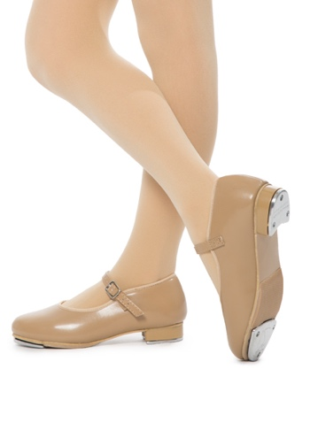
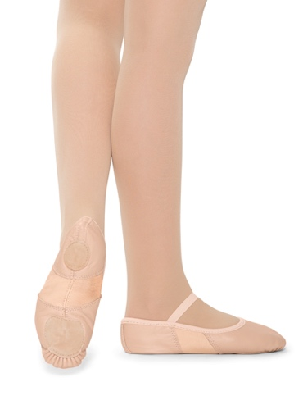

Pink Leather Ballet Shoes Tan Mary Jane Style Tap Shoes

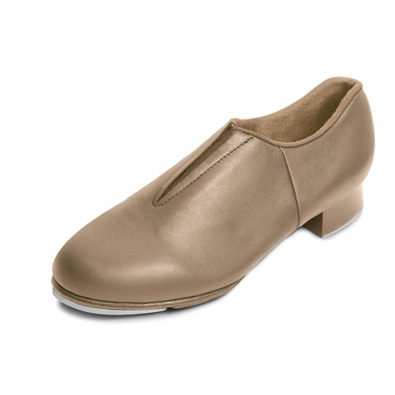
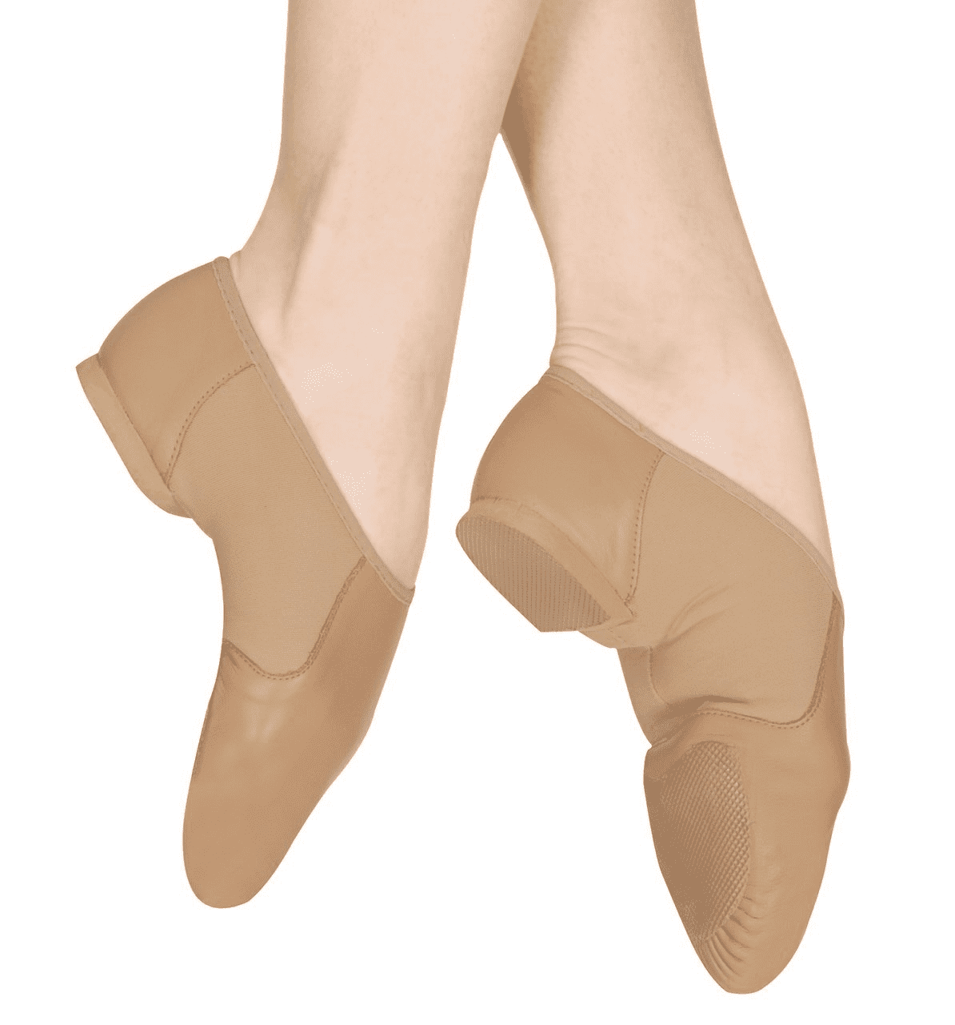

Tan T-Strap Jazz Shoes Tan Slip On Tap Shoes

